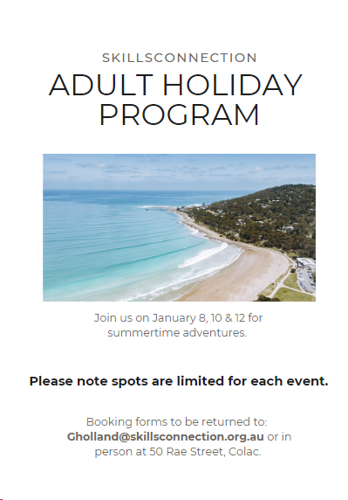

Important information
- Booking forms and queries to be returned to H/O 50 Rae Street, or email Gholland@skillsconnection.org.au
- Activities and places in activities are not guaranteed – this will be dependent on ticket and staffing availability.
- Times and dates of activities may change due to staffing and ticket availability.
- Bookings are made after activity selections have been submitted. If participants are unable to attend after the booking is made, they may still incur the activity fee (if we are unable to fill the participants position or unable to get a refund for activity).
- Please ensure participants are wearing appropriate clothing/footwear for activity, as not doing so may result in being unable to access the activity on the day.
- Activity fees may vary for each participant depending on companion card status.
- If your activity fees cannot be charged to your NDIS plan, you will be invoiced (Skills Connection is not taking any payment for activities on the day).
- By returning the attached expression of interest form it is an acknowledgement that you may be invoiced for program related fees (e.g. entry fees, transport).
- All medication required to be administered while on program MUST be in a Webster Pack or will NOT be administered.
- Pickups and drop offs will be communicated once bookings have been received and confirmed.
- All transport costs will be divided between participants.
- Start and end times may vary depending on the number of participants. Please be mindful of this flexible time, staff will do their best to adhere to stated times as possible.

Monday 8th January  Time: 10am – 1pm  Activity: More than Movement  Where: Studio 92  Cost: $10  What to bring: Comfortable clothing & water bottle.  Normal day pack of what each individual may require (e.g. change of clothing etc.). | Additional Information:  A fun and interactive class incorporating dance and movement.  This session will be run by local dance instructor Courtney Barrow.
Monday 8th January  Time: 9am – 6pm  Activity: Melbourne Museum & IMAX  Where: Melbourne  Cost: $26  What to bring:  Medications required (Webster pack), companion card, water bottle, snacks, and lunch.  Normal day pack of what each individual may require (e.g. change of clothing etc.). | Additional Information:  Travelling to Melbourne to watch a short film at the celebrated IMAX cinema.  Exploring the many experiences the Melbourne Museum has on offer.
Wednesday 10th January  Time: 9am – 3 pm  Activity: Bocce and outdoor lunch  Where: Lorne  Cost: $0  What to bring: Medications (Webster pack), water bottle, companion card, snacks, lunch.  Normal day pack of what each individual may require (e.g. change of clothing etc.). | Additional Information:  Travelling to Lorne to enjoy the beautiful outdoors and soak up some holiday vibes.  We will play bocce on the beach, wriggle our toes in the sand and enjoy lunch on the picturesque foreshore.  Taking lots of pics encouraged! | 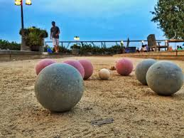
Wednesday 10th January  Time: 8:30am – 6:30pm  Activity: Ferry trip  Where: Queenscliff to Sorrento  Cost: $32 with concession, $36 without  What to bring: Medications (Webster pack), water bottle, Companion Card, Snacks, Lunch.  Normal day pack of what each individual may require (e.g. change of clothing etc.). | Additional Information:  Bus to Queenscliff where we will catch the Ferry to Sorrento.  Watch for dolphins and enjoy the scenic ferry ride.  Pack a picnic lunch to eat on the foreshore, go for a stroll along the pier and drink up the holiday atmosphere.  Catch the return ferry back to Queenscliff, then bus back home. | 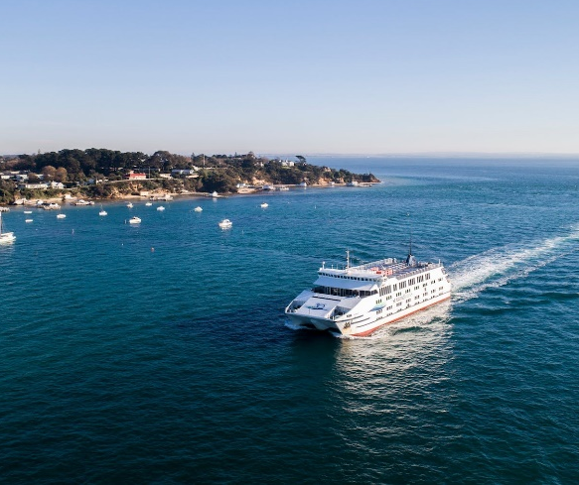
Friday 12th January  Time: 2:30pm – 9:30pm  Activity: Summer Night Market  Where: Lake Pertobe, Warrnambool  Cost: $0  What to bring: Medications (Webster pack), water bottle, snacks, money for dinner and shopping.  Normal day pack of what each individual may require (e.g. change of clothing etc.). | Additional Information:  Bring along your picnic rug or chair, browse the stalls, chat to the creators, tuck into some delicious food and enjoy a wonderful evening within the magnificent Lake Pertobe. | 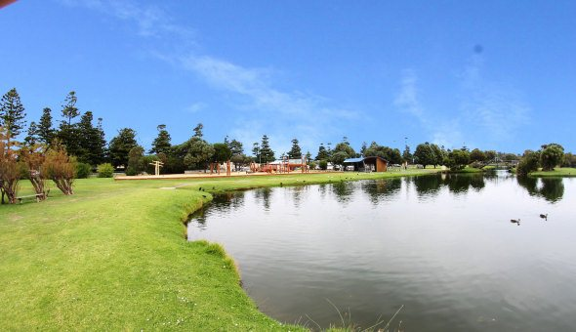
Friday 12th January  Time: 9:30am – 2:30pm  Activity: Swim & lunch  Where: Bluewater & Fish/Chips  Cost: $8 Swim, $$$ for lunch  What to bring: Medications (Webster pack), bathers, towel, change of clothes, water bottle, companion card, snacks & money for lunch.  Normal day pack of what each individual may require (e.g. change of clothing etc.). | Additional Information:  For those wanting something closer to home, we will keep it local with a refreshing swim at Bluewater Fitness Centre, followed by fish & Chips in the shade of the trees at Memorial Square.

